Joins continued

Agenda:

In today's session, we'll cover essential topics, including:-
🔸 Problem Statement
🔸 Joining Multiple Tables
🔸 Self JOIN
🔸 Cross JOIN
🔸 Non-Equi Joins

Summary of Previous Lecture:

Joins
- Joins are used to combine data from multiple related tables.

Types of Joins:
- INNER JOIN: Returns records with matching values in both tables.
- LEFT JOIN: Returns all records from the left table and matching records from the right table.
- RIGHT JOIN: Returns all records from the right table and matching records from the left table.
- FULL OUTER JOIN: Returns all records when there is a match in either table.

- Syntax for Joining Tables:
SELECT [columns to return]
FROM [left table]
[JOIN TYPE] [right table]
ON [left table].[field to match] = [right table].[field to match]

INNER JOIN
- The INNER JOIN joins two tables based on a common column and selects rows that have matching values in these columns.
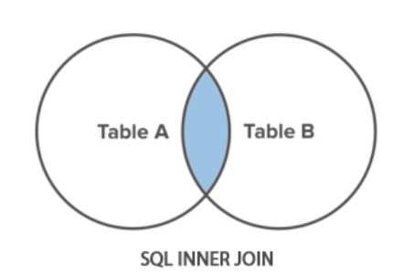
- Syntax:
SELECT *
FROM table1
INNER JOIN table2
ON table1.column = table2.column;

LEFT JOIN
- LEFT JOIN returns all rows from the left table with matching rows from the right table. Rows without a match are filled with NULLs.
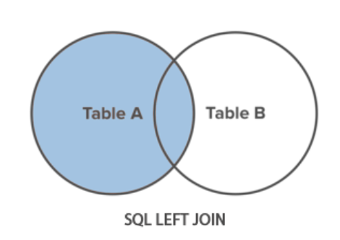
- Syntax:
SELECT *
FROM left_table
LEFT JOIN right_table
ON left_table.column = right_table.column;

RIGHT JOIN
- RIGHT JOIN returns all rows from the right table with matching rows from the left table. Rows without a match are filled with NULLs.
- It is similar to the LEFT JOIN, the only difference is that we are considering all the rows on the right table instead of the left table.
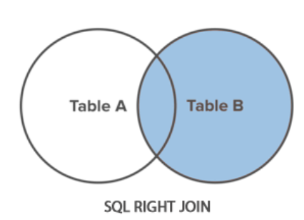

- Syntax:
SELECT *
FROM left_table
RIGHT JOIN right_table
ON left_table.column = right_table.column;

FULL OUTER JOIN
- FULL JOIN returns all rows from the left table and all rows from the right table. It fills the non-matching rows with NULLs.
- There is no direct way in MYSQL to perform the outer join. Thus, we perform it using a combination of other join types such as LEFT JOIN and RIGHT JOIN.
- We first use LEFT JOIN and RIGHT JOIN on the tables and then use UNION to combine the results and remove the duplicate rows.
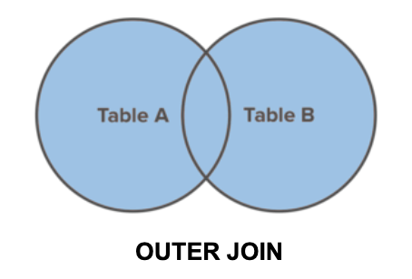
- Syntax:
SELECT *
FROM left_table
FULL OUTER JOIN right_table
ON left_table.column = right_table.column;

Or

SELECT * FROM tableA
LEFT JOIN tableB ON tableA.id = tableB.id
UNION
SELECT * FROM tableA
RIGHT JOIN tableB ON tableA.id = tableB.id

UNION
- UNION combines the results of two result sets and removes duplicates.
- UNION ALL doesn't remove duplicate rows.
- Syntax:
SELECT columns
FROM table1
UNION
SELECT columns
FROM table2;

